REGISTRATION MATERIALS

Welcome to Bethlehem Lutheran Church Summer Camp– a Christ-centered outdoor day camp! We are looking forward to having your child join us for a jam-packed summer as we go on field trips to many of the most popular museums and attractions in St. Louis. We’ll visit parks, swim, play games, and participate in a variety of activities unique to camp. Campers will also have daily devotional experiences, sing praises to God, and then, at the end of the summer, lead a Sunday worship service.

This packet includes the 2024 Parent Handbook, registration form, plus a tentative calendar of activities and the daily schedule. Please read everything thoroughly and complete all the registration materials.

We are so thankful that you are interested in our camp and look forward to having your child join us this summer. If you have any questions, please feel free to contact me at 214.600.2910 or via e-mail at seminarian.chris@behtlehemstlouis.org.

In Christ,

Bethlehem Lutheran Church Summer Camp Staff

Bethlehem Lutheran Church
Summer Camp
2153 Salisbury Street, St. Louis, Mo, 63137
314.231.9615
Bethlehem Lutheran Church - Summer Camp

Registration Form 2024
Please Print and fill out a separate registration for each child.

Camper’s Name: _____________________________ _________________________ Sex M / F
Last Name First Name
Camp Location: (Hyde Park, Walnut Park, Spanish Lake, North County (Grace), North County (Premium Adventure Camp)
Birthdate _____/_____/ _____ Grade Level Fall 2024 ______ at ___________________________ (School)
Address:_______________________________________ City___________________Zip_______
Church Name:_______________________________________ City: _________________________

Parent/Legal Guardian #1: Name _____________________________________________________
Home#:_____________________ Cell# _____________________ Work#_____________________
Email Address: ____________________________________________________________________
Parent/Legal Guardian #2: Name _____________________________________________________
Home#:_____________________ Cell# _____________________ Work#_____________________
Email Address: ____________________________________________________________________

Is your child currently staying/living with the parent(s)/legal guardian(s) named above? YES NO
If no, please fill out the information below. Child named above is currently living with:

Name____________________________________________________ Relationship__________________________
Address:______________________________________________City________________________Zip___________
Home #:_________________________ Cell #: _______________________ Work #:__________________________
Email Address: _________________________________________________________________________________

Additional Authorized Drop off & Pick Up/Emergency Contacts (please provide two contacts if possible)
Name_______________________________________________________ Relationship__________________________
Address:________________________________________________City_________________________Zip___________
Home #:_________________________ Cell #: ________________________ Work #:___________________________

Name_______________________________________________________ Relationship__________________________
Address:________________________________________________City_________________________Zip___________
Home #:__________________________ Cell #: ________________________ Work #:__________________________
Under no circumstances will a child be released to anyone not known to the camp without prior authorization from the parents/guardians.

New Summer Camp Families: How did you hear about Chapel Summer Camp? _______________________________________

If referred, please name the summer camp family who referred you: ______________________________________________

Swimming
Safety is our number one concern. Certified lifeguards along with our own identifiable camp counselors will be attentive in
providing a safe environment while at the pool.

My child may go in the pool (please check): YES NO

For your child’s safety and our knowledge, your child is (please check):

good swimmer fair swimmer non-swimmer

Summer Camp T-Shirt

T-shirts must be worn on all field trip days. (Registrations received after May 13 may have limited sizes available.)

Please circle your child’s T-shirt size: Child sizes: XS S M L
Adult sizes: Small Med Large XL

Would you like an extra T-shirt for $20? (one shirt is included) Yes No How many extra T-shirts? ________

If purchasing extra T-shirts, please include the payment with the registration fee.

Required Release

Indemnification by Parent or Guardian of Applicant
I/We, the parent(s)/guardian(s) of the minor child listed on this application do hereby release Bethlehem Lutheran Church and any and all adult supervisors, directors, counselors, volunteers, church staff, or agents from any and all debts, claims, demands, actions, damages, causes of action, judgment or suits of any kind which may arise or be occasioned as a result of the applicant’s participation in the Bethlehem Lutheran Church Summer Camp in the event of any accident; en route, during and returning from Bethlehem Lutheran Church sponsored field trips and all summer camp activities at Bethlehem Lutheran Church. I/We also release in the event of any accident, transportation provided by bus and Bethlehem Lutheran Church’s vans and authorized drivers. I/We will pray for the safety and growth of all participants during the field trips.

Photographic Release
I/We hereby grant Bethlehem Lutheran Church the absolute right and permission to use, reuse, publish and republish photographic materials of my child to illustrate, promote and advertise Bethlehem Lutheran Church Summer Camp, Bethlehem Lutheran Church Lutheran Church, and their programs in publications and websites. Names will not be used in print or online publications.

Parent Handbook
I/We acknowledge that I have read the Parent Handbook and understand the policies of Bethlehem Lutheran Church Summer Camp.
I/We will work with the camp to uphold the Summer Camp Covenant as it is written in the handbook. My/Our child and I/we have talked about this covenant prior to attending camp. I/We also acknowledge that for premium camps, payment for each week of Summer Camp is due on the first day of each week that my child attends in the form of check or cash. Failure to make payments on time may result in dismissal from camp.

Valuables
I/We will not send my/our child to camp with any valuables including iPods, cell phones, money, etc. In the event that my/our child does bring an item of value to camp and it is lost, stolen, or destroyed, I/we will not hold Bethlehem Lutheran Church Lutheran Church, and any and all adult supervisors, directors, counselors, or church staff responsible. I/we recognize that there is not a need for any of these devices to be in camp and in the event that I/we need to contact my child during the camp day, I/we will call the church office.

__________________________________________ __________________________________________
Signature of Parent or Legal Guardian Signature of Parent or Legal Guardian

_____________________________________ _____________________________________
Date Date
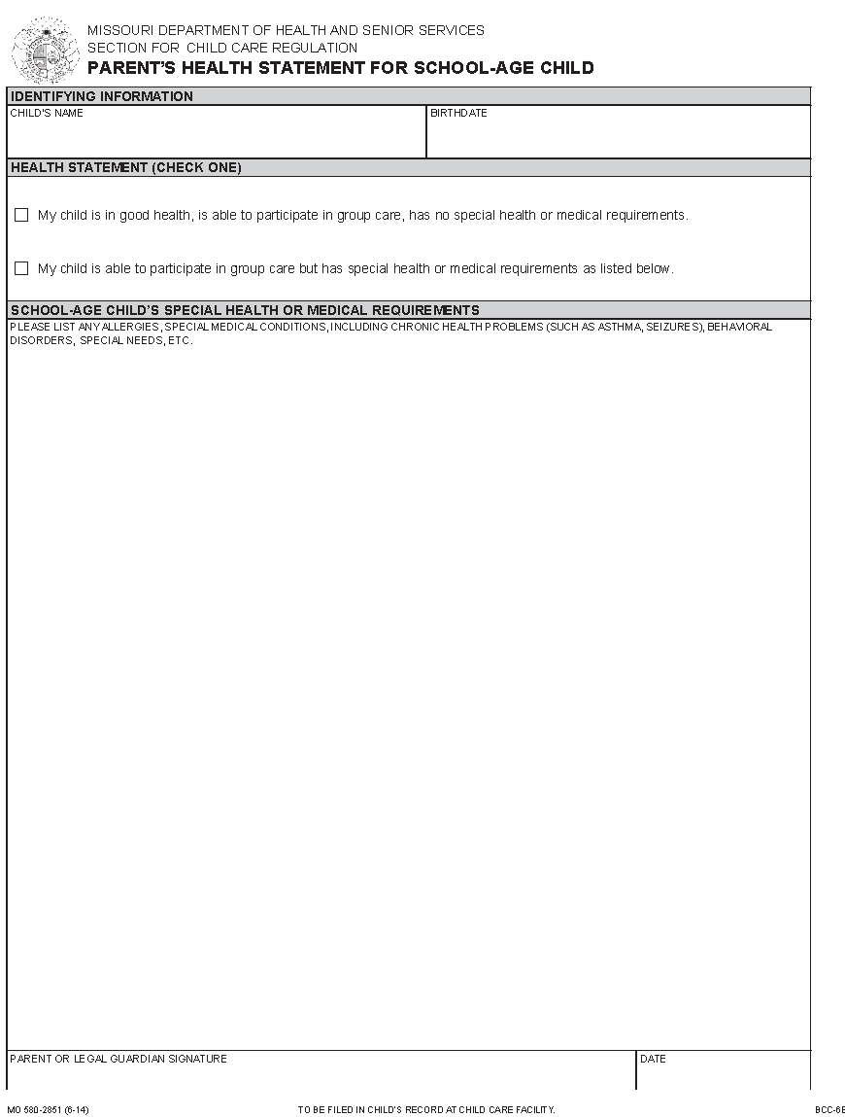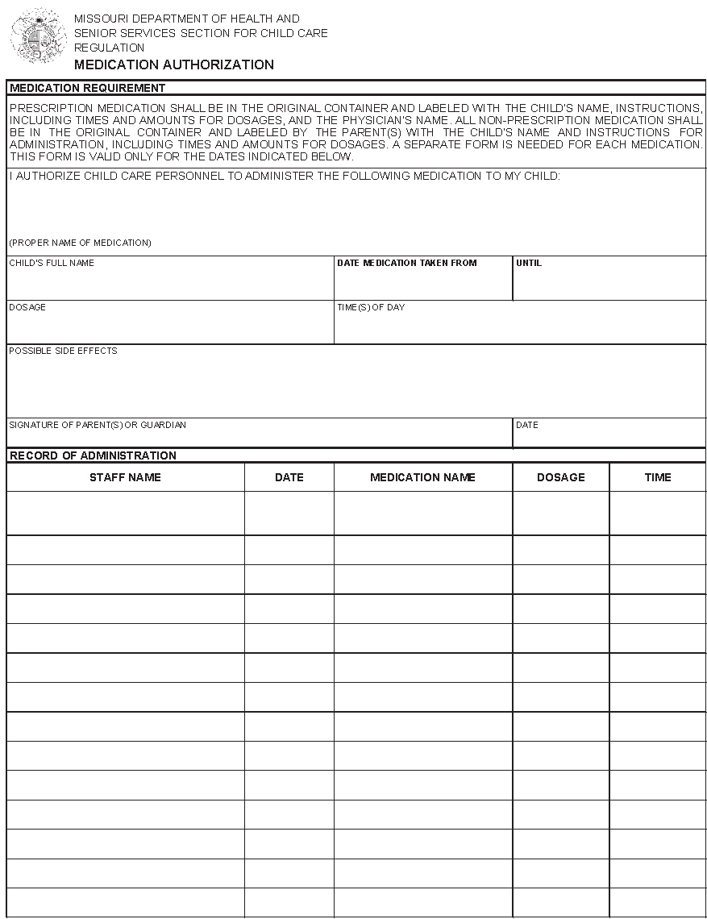

Medical Release and Physician / Insurance Information

has my permission to attend all summer camp
Name of Child
activities and field trips sponsored by Bethlehem Lutheran Church – Summer Camp.

This consent form also gives permission to seek whatever medical attention is deemed necessary, and releases the Church and its staff of any liability against personal losses of the named child.

I/We the undersigned have legal custody of the student named above, a minor, and have given my/our consent for him/her to attend events being organized by the Church. I/We understand that there are inherent risks involved in any ministry or athletic event, and I/We hereby release the Church, its pastors, employees, agents, and volunteer workers from any and all liability for any injury, loss, or damage to person or property that may occur during the course of my/our child’s involvement. In the event that he/she is injured and requires the attention of a doctor, I/We consent to any reasonable medical treatment as deemed necessary by a licensed physician. In the event treatment is required from a physician and/or hospital personnel designated by the Church, I/We agree to hold such person free and harmless of any claims, demands, or suits for damages arising from the giving of such consent. I/We also acknowledge that I/we will be ultimately responsible for the cost of any medical care should the cost of that medical care not be reimbursed by the health insurance provider. Further, I/We affirm that the health insurance information provided below is accurate at this date and will, to the best of my/our knowledge, still be in force for the student named above. I/We also agree to bring my/our child home at my/our own expense should they become ill or if deemed necessary by the camp ministry staff member.

Primary Physician: ___________________________________________________ Phone #__________________________
Preferred Hospital: __________________________________________________ Phone #__________________________

Name of Person carrying insurance coverage _______________________________________________________________

Medical Insurance Company Name and Policy Number ________________________________________________________

Parent/guardian signature: _________________________________________________ Date: _______________________

Parent/guardian signature: _________________________________________________ Date: _______________________

In the event your child needs certain over-the-counter medications, the summer camp director / lead counselors may choose to provide medication to the camper to feel better during the day. The dosages given will be those listed on the sides of the container of medications. Below is a list of authorized over-the-counter medications which may be given to your child. In all cases, this will be documented and the parents alerted as soon as possible. Please CIRCLE all medication your child may be given, and CROSS OUT all medication your child does not have your permission to take (without your verbal or written consent).

Lotion Sunscreen Ibuprofen: Dose ________
Tylenol (Acetaminophen): Dose _________ Pepto-Bismol Benadryl Hydrocortizone Cream (anti-itch)

SUMMER CAMP ATTENDANCE CAMPER NAME________________________________

We recognize that your summer schedule may be subject to change, but please provide us with the most
accurate information currently available and inform us of any scheduling changes as soon as possible.
This helps us with billing, planning field trips, and scheduling counselors for each day.
Please indicate which days you intend on sending your child to summer camp with an X.

Week One: June 3rd - June 7th
Monday | Tuesday | Wednesday | Thursday | Friday

Week Two: June 10th - June 14th
Monday | Tuesday | Wednesday | Thursday | Friday

Week Three: June 17th - June 21st
Monday | Tuesday | Wednesday | Thursday | Friday
 |  | NO CAMP

Week Four: June 24th - June 28th
Monday | Tuesday | Wednesday | Thursday | Friday

Week five: July 1st- July 5th
Monday | Tuesday | Wednesday | Thursday | Friday
 |  |  | NO CAMP | NO CAMP

Week Six: July 8th - July 12th
Monday | Tuesday | Wednesday | Thursday | Friday

Week Seven : July 15th - July 19th
Monday | Tuesday | Wednesday | Thursday | Friday

Week Eight: July 22nd - July 26th
Monday | Tuesday | Wednesday | Thursday | Friday

Week Nine: July 29th - August 2nd.
Monday | Tuesday | Wednesday | Thursday | Friday

REGISTRATION CHECK-LIST

The following items should be included with each registration:

__________ Registration (complete and sign)

__________ Non-refundable registration fee for adventure camp + payment for extra t-shirts(s)

__________ Health Statement (complete and sign/required by the State of Missouri)

__________ Immunization Record (required by the State of Missouri)

__________ Medication Authorization (if applicable)

__________ Medical Information and Release (complete and sign)

__________ Completed Summer Camp Attendance Form

Please mail to or drop off your Summer Camp Registration at:

For NO COST Camps:

Bethlehem Lutheran Church
2153 Salisbury Street, St. Louis, Mo, 63137
314.231.9615

OR

For Adventure Campers:

Chapel of the Cross - Lutheran
11645 Benham Rd. St. Louis, Mo, 63136
314-741-3737

